**How to capture and replay slog on SharkL TW version**

Version: 1.1

Date: Dec 5, 2014



[www.spreadtrum.com](http://www.spreadtrum.com)

**1.How to capture slog**

## 1.1 Key String settings on phone

**1.1.1Open Samsung Keystring app and input** “*#9900#” , **then click Send Keystring button.**

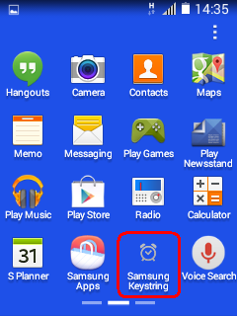 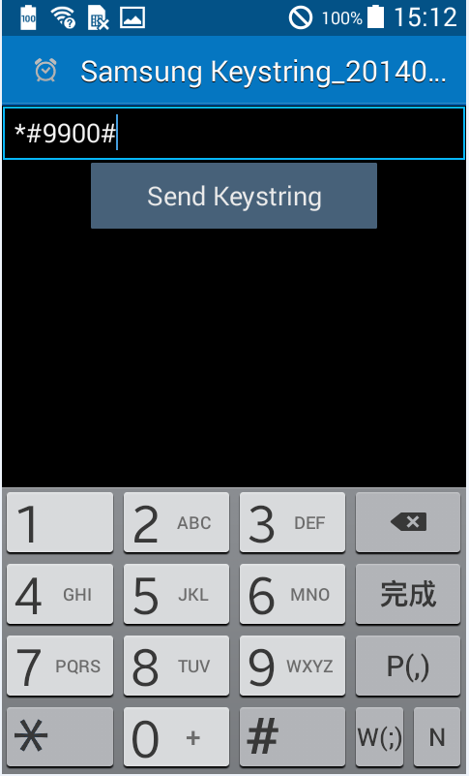

**1.1.2Click “ Silent Log: Off” and select” ARM_DSP”, then you can get the slog**

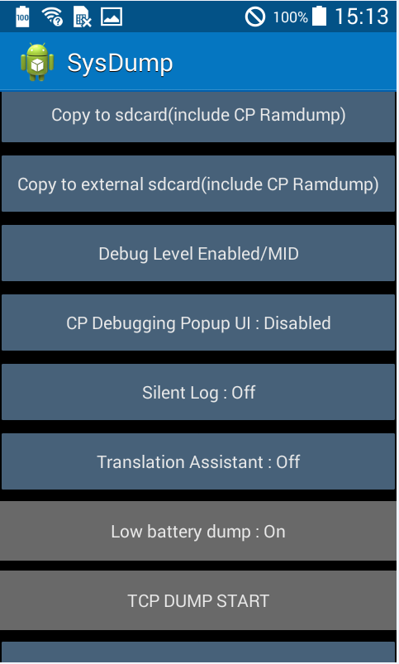 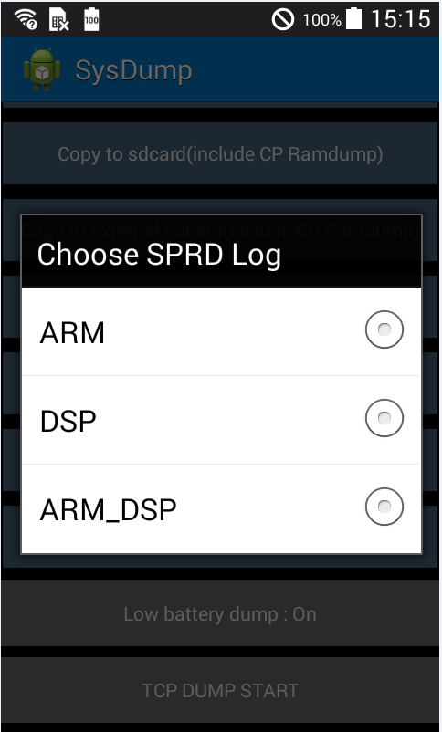

## 1.2 Rebooting with SD card

**When you finish the first step , the handset will restart.**

**You have to insert SD card on the phone.**

**Then you can do some test on the test phone.**

## 1.3 Check slog

**1.3.1 Put the SDCard out , use a card reader to connect PC.**

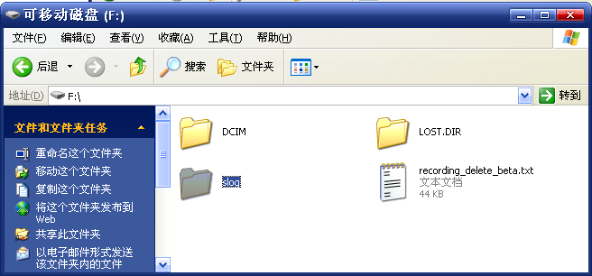

**1.3.2 The SDCard can only capture two slogs.**

**The first floder is the latest slog , it ‘s named by the test time.**

**The second floder is** **the previous slog.**

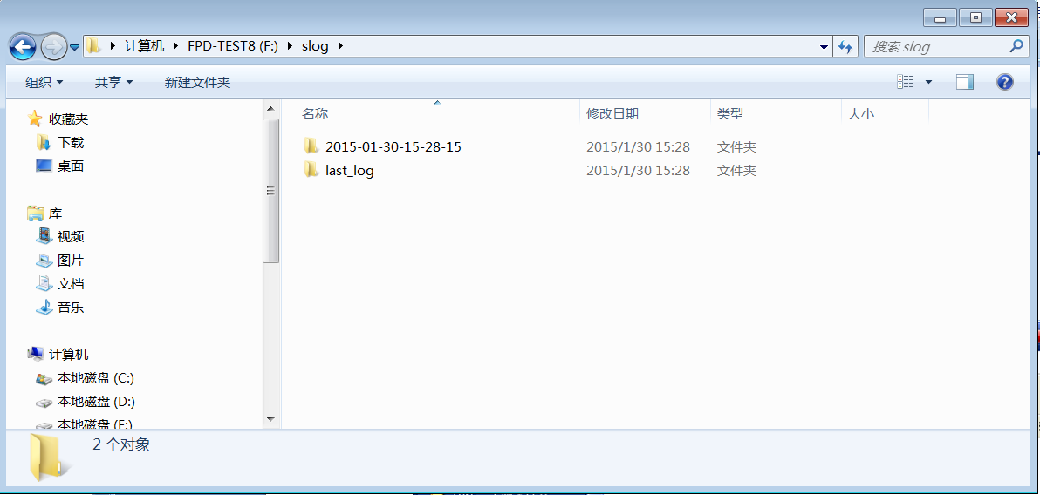

**2.How to replay Slog**

## 2.1 Find the cplog path

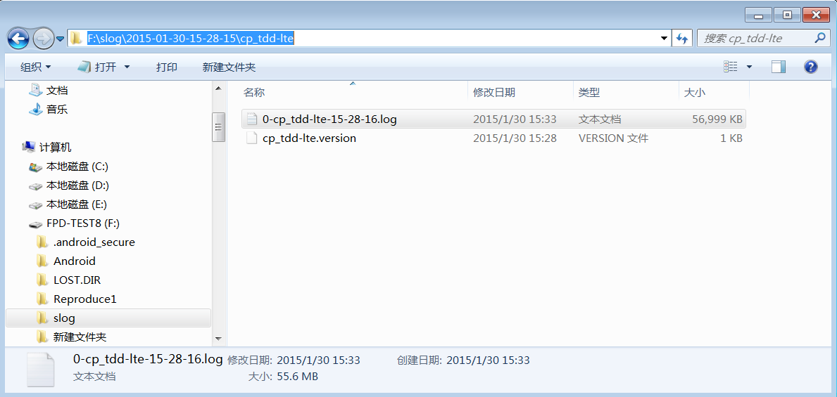

## 2.2 Using armlog tool and DSP tool for log playback

**2.2.1 ChannelServer**

**Open ChannelServer**

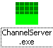 **is the tool to allow capture both Armlog and Dsplog, and also can only capture one of them.**

**Settings for ChannelServer**

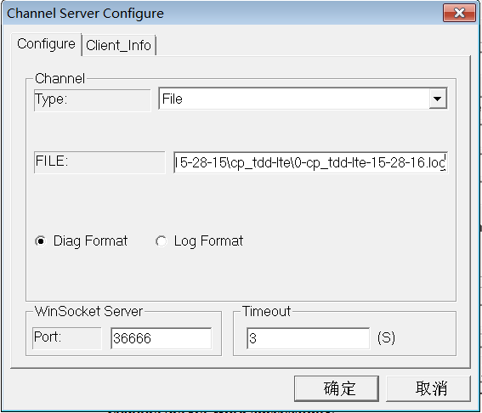

CP log path in slog

**Channel Server work successfully**

C:\Documents and Settings\wenchao.yan\桌面\未命名.bmp

**2.2.2 Armlog**

**Open ArmLogel**

C:\Documents and Settings\wenchao.yan\桌面\未命名.bmp **is the tool to capture Armlog , double-click to open it.**

**Open Dll**

C:\Documents and Settings\wenchao.yan\桌面\未命名.bmp

**Settings for ArmLogel**

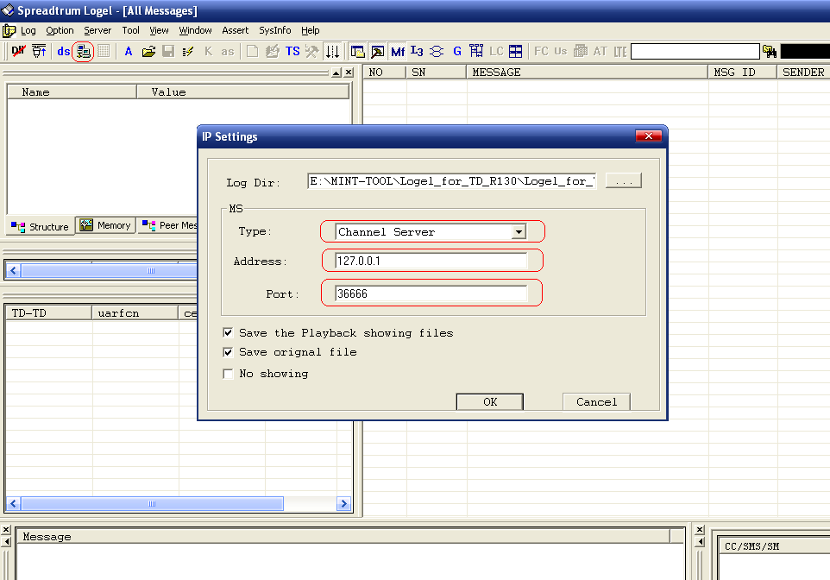

**Connect**

C:\Documents and Settings\wenchao.yan\桌面\未命名.bmp

**Start Logging**

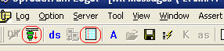

C:\Documents and Settings\wenchao.yan\桌面\未命名.bmp

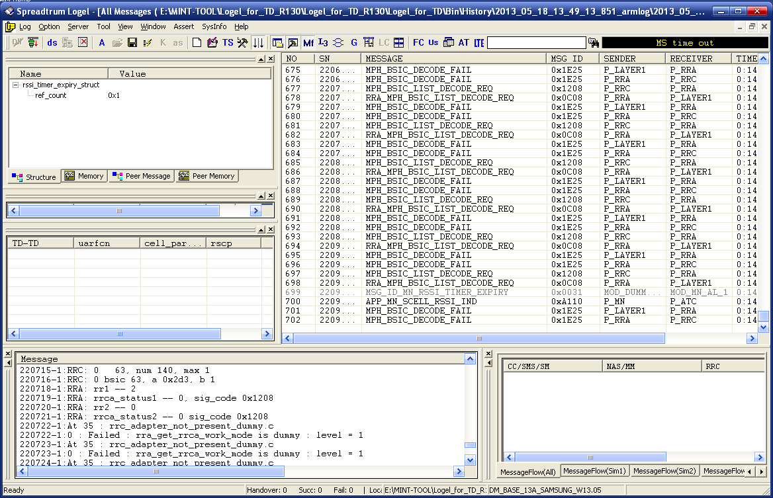

**Save Armlog file**

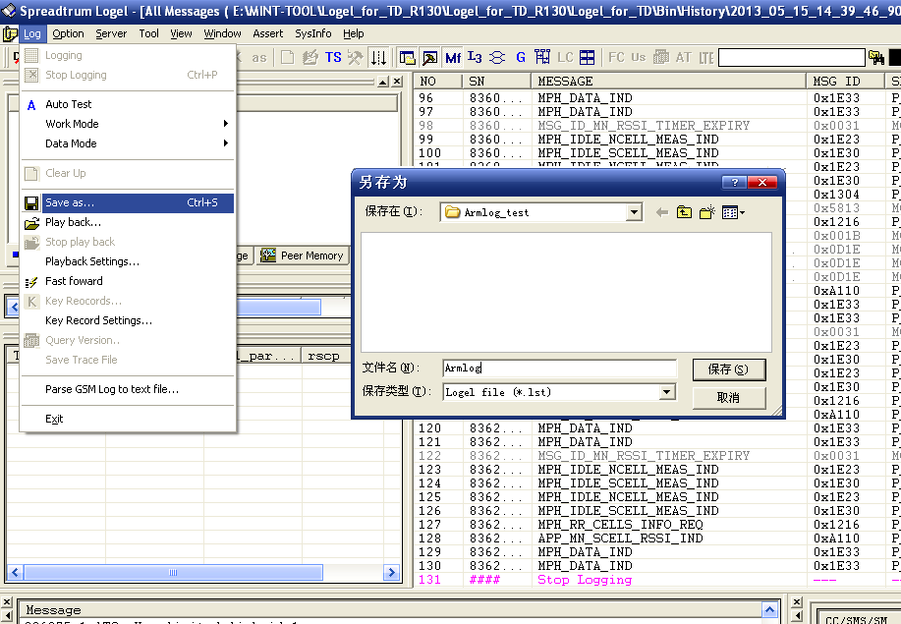

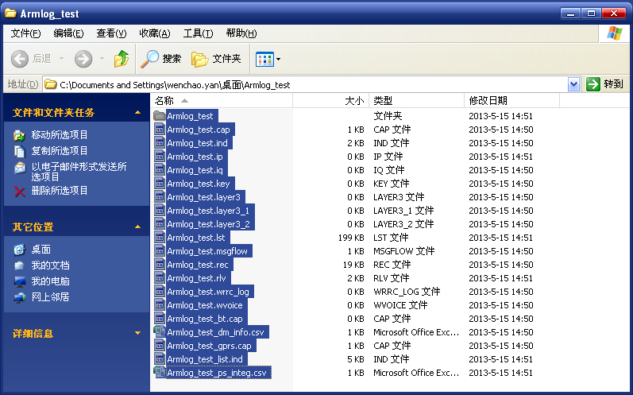

**2.2.3 Two Dsplogs**

**Open DspLogger**

**Settings for DspLogger and select the model (eg:TG-DSP)**

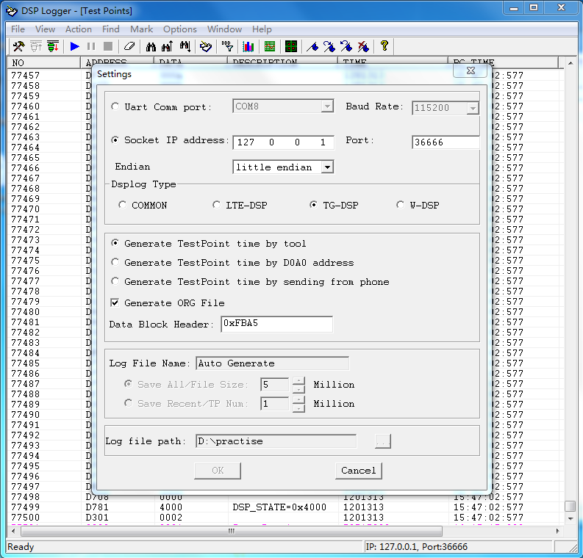

**Connect**

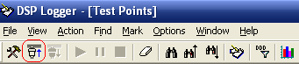

**Start logging test points**

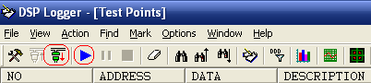

**Logging**

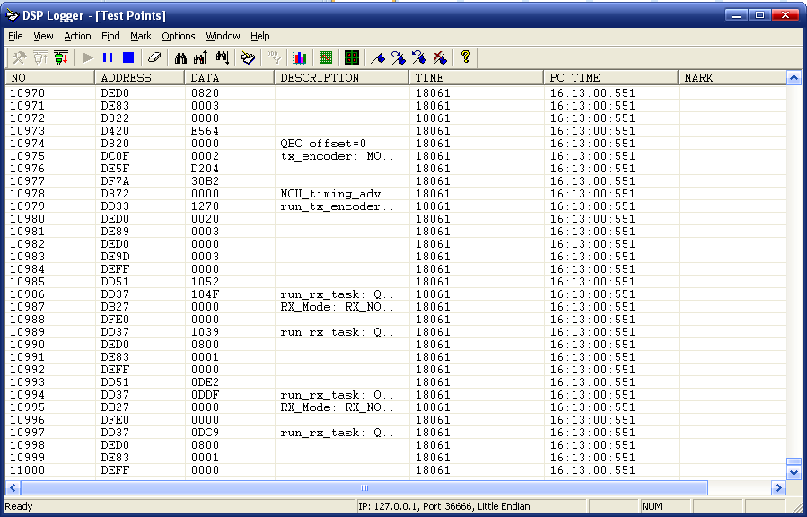

**Open DspLogger again (please don’t close the former Dsplogger)**

**Settings for DspLogger and select another model (eg:LTE-DSP)**

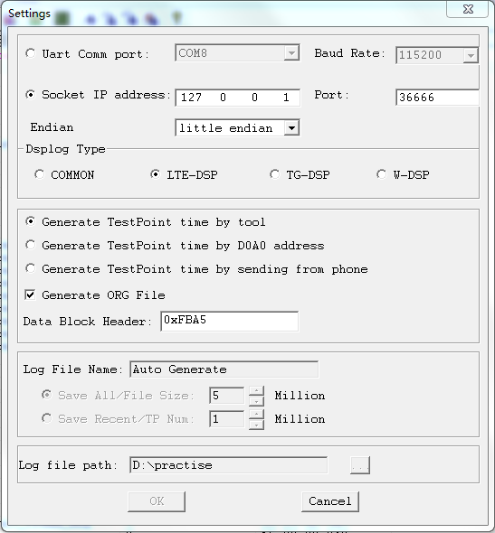

**Do the same step as above to connect and start logging**

**Save the two Dsplog files**

